

`

TOM Integration
Interface Specification
On
Valid Mod Number Range
From IKB to
GPM

[S059]

Project BEN Code: | W60416
Author: | Nitin Singhai
Date: | 08/03/2007
Version: | 0.2
Status: | Draft
Modified By: | Nitin Singhai
Reviewed By:

Change Record

Author | Date | Version | Change Reference, description
Nitin Singhai | 08-03-2007 | 0.1 | Draft
Nitin Singhai | 14-05-2007 | 0.2 | Updated field definitions as per the latest Table layouts provided by JDA and GPM Team.
Nitin Singhai | 18-06-2007 | 0.3 | Updated field definitions as per the latest Table layouts provided by JDA and GPM Team.

Reviewers

Name | Position
Andrew Barker | Solution Architect

At least one reviewer is required.

Sign-Off

By signing this form, I understand and agree with the contents of this document.

Business Owner/Customer | Andrew Barker
Position | Engagement Architect
Signature | <Physical signature or via email approval>
Date | dd/mm/yyyy (<version signed off>)

Distribution List

Name | Date of Issue | Version
Andrew Barker
John Cowper
David Onyett
Venkateswara Rao
Mary Welch

Document Source
DocShare: UK IT/TOM Integration/Shared Documents

Related Documents

A complete interface specification requires three documents- an Interface Specification, an Information Architecture Context diagram, and a Mapping spreadsheet. This section identifies these documents plus other documents as appropriate.

Information Architecture Context diagram

Mapping spreadsheet
S059 - Valid Mod Range (IKB to GPM) Mapping Specification

Other Reference Documents
Tesco - Event Schedule Update v1 4 (2)
http://docshare/UK%20IT/Space%20Range%20and%20Display/Shared%20Documents/Forms/AllItems.aspx?RootFolder=%2fUK%20IT%2fSpace%20Range%20and%20Display%2fShared%20Documents%2fJDA%20Documentation%2fBusiness%20Systems%20Design&View=%7bD9948B22%2dB5EB%2d483F%2d9949%2d19E088D48D25%7d

Table of Contents
1 Introduction 6
1.1 Purpose of Document 6
1.2 Background 6
1.3 Scope 6
2 Description and Requirements for the End-to-End Interface 7
2.1 Description of the End-to-End Interface 7
2.2 Architecture 7
2.3 Requirements of the End-to-End Interface 7
2.4 Non-Functional Requirements of the End-to-End Interface 8
3 Processing Required in the Extract Stage of the Interface 9
3.1 Scope 9
3.2 Source Message Schema 9
3.3 Message Transport Details 9
4 Processing Required in the SSIS Stage of the Interface 10
4.1 Scope 10
4.2 Package Overview 10
4.3 Data Validation 10
4.4 Filtering 10
4.5 Mapping 10
4.6 Target Message Schema 10
4.7 Message Transport Details 11
4.8 Naming and Configuration 11
4.9 Environment and Security Context 12
4.10 Non-Functional Requirements 12
5 Processing required in the <third stage of the interface> 13
5.1 Scope 13
5.2 Data Validation 13
5.3 Filtering 13
5.4 Mapping 13
5.5 Target Message Schema 13
5.6 Message Transport Details 13
5.7 Naming and Configuration 13
5.8 Environment and Security Context 13
5.9 Non-Functional Requirements 13
6 Testing Deliverables 14
7 Deployment 15
8 Assumptions and Outstanding Issues 16
8.1 Assumptions 16
8.2 Outstanding Issues 16
Appendix A Volumes 17
Appendix B Glossary 18
Appendix C Document Control 19

Introduction

Purpose of Document
The purpose of this document is to describe the interfacing requirements w.r.t Valid Mod Range in a Store between the IKB and GPM Application. The document is of a sufficiently technical in nature to allow a developer to build an actual interface. Additionally the document contains detail that might sit logically within a Technical System Design (TSD) document, but is contained here for expediency. There is therefore no associated TSD for this interface.

This interface is for US and Turkey implementation.

Background
As part of the process of managing Space, Range and Display activities in store it is important to identify that the store has accurately completed all space range and display activities. This will help the centre to understand how well stores are conforming to the planograms. This interface provides the Valid Mod Range that exists in a Store.
In Tesco Operating Model program, there is requirement to bridge the functionalities of enterprise applications including IKB and GPM. To achieve this functionality, high level process flow architecture has been designed and approved by Tesco’s Enterprise Architecture team. As part of this process flow architecture there is a set of interfaces that has been identified to be developed for product mapping.

Scope
The Interface Specification covers:

- audit requirements across the interface
- security requirements across the interface
- timing/frequency requirements or constraints
- support requirements
- archiving
- the data format to be used for the interface at each stage (e.g. xml messages)
- the normal processing required at each stage
- recovery from failure required at each stage
- volumes.

Note that it is Tesco strategy to avoid placing any business logic in integration layer processing.

Description and Requirements for the End-to-End Interface

Description of the End-to-End Interface
This interface extracts valid Mod range details from IKB using a SQL Server Connection and uploads into the GPM Holding Table using SSIS. The Upload is a full upload in nature.

Architecture
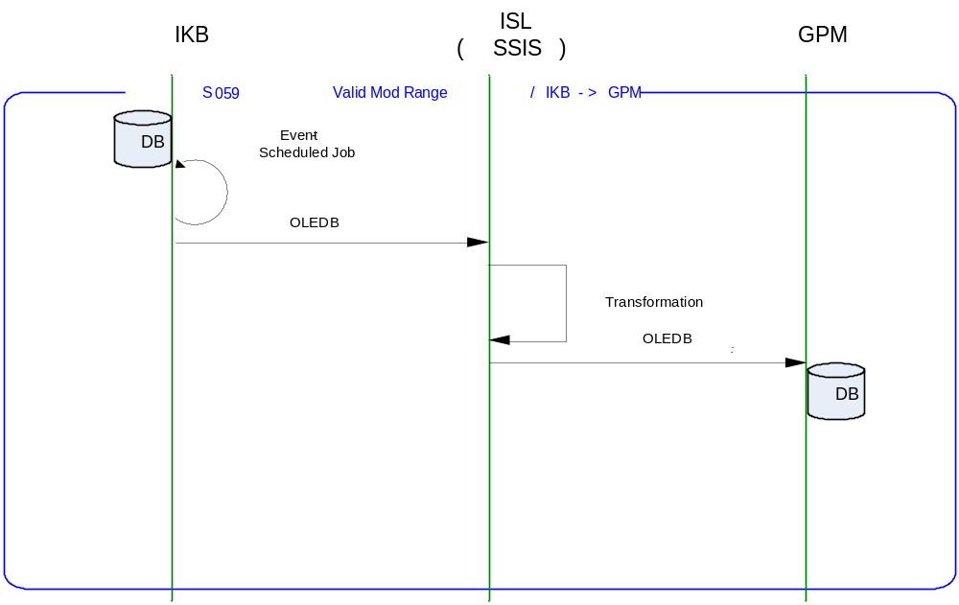

Requirements of the End-to-End Interface
The interface will run on scheduled basis, and consists of a SQL Server Integration Services package that extracts data from the IKB, and formats it into the target Table format.

The interface should transfer the data for Valid Mod Range from IKB to GPM holding table at a pre-configured time (to be determined). After successful completion, another GPM process would then upload the Valid Mod Range data to the core tables of GPM.

The interface will make use of the audit and traceability components that are being developed as part of the Operational Framework stream. These components will be pluggable, and will be useable from BizTalk, RTI and SSIS. At the time of writing (2007-03-08) the components are in design. Although not ready for use, they are included on the Information Architecture Context diagram where their functionality is required. Developers should put a ‘placeholder’ in their code / configurations as appropriate.

Non-Functional Requirements of the End-to-End Interface

Audit Requirements | The interface will use the components provided by the Operational Framework to satisfy audit requirements.
Security Requirements | The interface executes within a secure private domain. There is no additional security considerations required.
Timing/Cut-off Constraints | To be finalised.
Performance Requirements | The interface should be capable of extracting data from IKB through SSIS Service layer, delivering the resulting data to Holding Table tbl_ModDetails_Inbound before the identified cut-off time. The interface should run on scheduled batch basis.
Reliability and Availability Requirements | The interface-run should be atomic in nature. Appropriate mechanisms should be in place to raise/alert appropriate parties (TBD).
Scalability Requirements | No Scalability requirement. The requirement is to deliver a single extract. It is anticipated that the volume of data transferred will continue to remain within the capability provided by this implementation.
Operational Support Requirements | The successful delivery, failure in the creation of the extract, and failure in message transport, must be recorded by the Integration Management Operational Framework (IMOF). In the event of failure, an alert should be raised. Alerts will be monitored by HSC Operations and passed to support as appropriate. (Refer to 8.3 Outstanding Issues).
Likelihood of Change Requirements | There is no such requirement
Cultural/Global Consideration Requirements | Although multi-byte character set support is not required for US or Turkey, the interface will support multi-byte character sets through integration.
Legal Requirements | N/A
Compliance To Standards Requirements | No compliance exceptions.

Processing Required in the Extract Stage of the Interface

Scope
This section describes the data sources required by this interface and the services used to access the data.

Source Message Schema
The data for this interface resides in the IKB in a holding table.

Holding Table Field Name | Type | Length | Mandatory | Description
Store_No | Integer |  | Yes | Store Number
Module_number | varchar | 50 | Yes | Module Number in Store
IL_Time_stamp | Datetime |  | Yes | Integration layer set to current datetimstamp when all records fetched successfully.

Message Transport Details

Feature | Specification | Additional Information
Source System Name | IKB
Source Platform / OS | Windows 2003 Server
Source Physical Location | SQL SERVER 2005
Source Underlying Data Storage Technology | RDBMS
Target System Name | SSIS
Target Platform / OS | Windows 2003 Server
Target Physical Location
Target Underlying Data Storage Technology
Transfer Function | HTTP (Put/Post) □  HTTPS (Put/Post) □  Message Queue □  FTP □  File Drop(Windows) □  (XCOM) □  SSIS ☑
Data Format. | XML □  Delimited □  Positional □  RDBMS ☑
Decryption/Encryption | No
Decompression/Compression | No
Transmission Mode | Synchronous □  Asynchronous ☑  Bulk Data □
Real-time/Scheduled Batch | Not yet decided
Archiving | There is no requirement to archive the messages.
Logging | Log via the Operational Framework.
Error Handling | Not yet decided  Processing should prevent sending of duplicate messages, unless this occurs during recovery from failure.

Processing Required in the SSIS Stage of the Interface

Scope
This section describes the discrete steps within the SSIS package to extract and format data. The target schema is included in this section. This segment will process the data picked from IKB database and transform into needed format which is required by GPM holding table. After processing, transformed data will get loaded into GPM holding table (tbl_ModDetails_Inbound). In turn the holding table data will get loaded into tbl_ModDetails in GPM database.

Package Overview
SSIS extracts the Valid Mod Range data from IKB via SQL Server OLEDB connection, at a predefined time. In turn, the data is inserted into an Intermediate table at GPM.

Data Validation
N/A.

Filtering
There is no filtering requirement.

Mapping
Please refer Page iii for location of mapping document.

Target Message Schema
Holding Table Field Name | Type | Length | Mandatory | Description
ModNumber | Varchar | 50 | Yes | This field will contain mod number displayed on the mod label.
StoreID | Integer |  | Yes | This field contains the ID of the Store.
InsertDate | smalldatetime |  | Yes | Insert Current Datetime

Message Transport Details
For messages destined for GPM system, the following applies.

Feature | Specification | Additional Information
Source System Name | SSIS
Source Platform / OS | Windows 2003 Server
Source Physical Location | SQL Server 2005 database
Source Underlying Data Storage Technology | RDBMS
Target System Name | GPM
Target Platform / OS | SQL Server
Target Physical Location
Target Underlying Data Storage Technology
Transfer Function | HTTP (Put/Post □  HTTPS (Put/Post) □  Message Queue □  FTP □  File Drop (Windows) □  (XCOM) □  RTI File Adapter □  SSIS ☑
Data Format | XML □  Delimited □  Positional □  RDBMS ☑
Decryption/Encryption | No
Decompression/Compression | No
Transmission Mode | Synchronous □  Asynchronous ☑  Bulk Data □
Real-time/Scheduled Batch | Scheduled Batch
Archiving | N/A
Logging | Log via the Operational Framework.
Error Handling | Not yet decided

Naming and Configuration

SSIS
Package Name: TOM.S059.IKBtoGPM.ValidModRange.dtsx
Name
<Placeholder for other package components/steps>
<Placeholder for other package components/steps>

Environment and Security Context
Account details will be included here once we have visibility of the environments.

Non-Functional Requirements
On successful delivery of the data to the target system, the audit log should be updated via the Operational Framework pipeline component or adapter (to be determined).

In the event of a failure of transformation of data should be written to the failed log database, and an alert should be raised.

Processing required in the <third stage of the interface>

Scope
There is no intermediate staging is required for this interface. So this section is not applicable.

Data Validation
Not Required

Filtering
Not Required

Mapping
Not Required

Target Message Schema
Not Required

Message Transport Details
Not Required

Naming and Configuration
Not Required

Environment and Security Context
Not Required

Non-Functional Requirements

Not Required

Testing Deliverables
This section should contain a list of discrete deliverables. The following table is an illustrative template only. The exact deliverables will depend on the technologies employed in the interface.

Deliverable | Description
TBD <stored proc name>
TBD <stored proc name>
TBD <service name>
TBD <SSIS package name> | Package
TBD <script name> | Unit Test Scripts. Scripts should be provided to:  - create databases (including stored procedures).  - populate with the minimum set of test data to satisfy functional requirements  - notes showing how to use scripts and describing the functions tested.
<installer> | Installers as appropriate to the technology being used.

Deployment

Assumptions and Outstanding Issues

Assumptions
ID | Assumption

Outstanding Issues
ID | Issue | To be addressed by
1 | Timings and cut-off constraints need to be defined. Require input from GPM | GPM Solution Architects plus Information Architect.
2 | Alert numbers/identifiers are yet to be defined | Solution Architect
3 | The design of the IMOF is still being worked and will require retro-fitting to the interface. | IMOF team
4 | Maintenance mechanism of IKB holding table to be decided | Solution Architect
5 | Time window for updating the IKB holding table to be decided | JDA Team

- Volumes
- Glossary

Acronym | Term | Description
EAI | Enterprise Application Integration | The process of meeting the data requirements of applications by providing a message based transport from disparate data sources across all forms of enterprise technology.
EAI Layer | Enterprise Application Integration Layer | Refers to the integration services provided to implement EAI. In contrast to the EIA Layer for data services. See below.
EIA | Enterprise Information Architecture | Creation of a strategic single view of data across the enterprise.
Interface | Interface | Many definitions exist for 'interface'. In general, 'interface' refers to the link between a data source and a data target. And there are properties of the interface in this context. However more specifically 'interface' refers to one end of a data link, hence the terms source interface and target interface, and both the source interface and the target interface will have specific properties of their own.
RMS | Retek Merchandising System | Retek Merchandising System is getting installed for TESCO Merchandising operations in US. This system will governs the Merchandising operations; Receive base Master & Transaction data and from other systems and Provide data to next level of operation system as part of Retail systems chain.
GPM | Group Product Mapping | SQL Server Database provided by Group Product Mapping Application for loading Product details.
IKB | Intactix Knowledge Base | SQL Server Database provided by JDA Intactix to maintain Space Planning and Floor Planning data.
IMOF | Integration Management Operational Framework | IMOF is a framework which is pluggable to any Biztalk, RTI and SSIS for alerting, exception handling, defining rules, scheduling etc

- Document Control
Change Record

Author | Date | Version | Change Reference, description
Nitin Singhai | 08-Mar-2007 | 0.1 | Draft
Nitin Singhai | 14-May-2007 | 0.2 | Updated field definitions as per the latest Table layouts provided by JDA and GPM Team.
Nitin Singhai | 18-Jun-2007 | 0.3 | Updated field definitions as per the latest Table layouts provided by JDA and GPM Team.

Related Documents

Author | Date | Version | Title

Distribution

Name | Position | Approver/Contributor/Other
Jon Braggs | Enterprise Architect
Andrew Barker | Solution Architect
Welch Mary | SRD Manager TOM Integration

